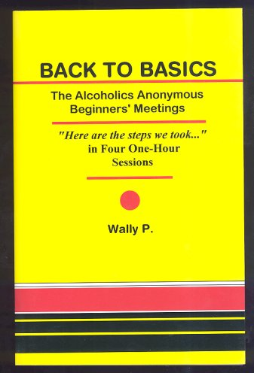
Let’s get ….
BACK TO THE BASICS
of recovery
With Wally P. (Tucson, AZ) A.A. Archivist and Historian

SPECIAL WEEK PACKAGE VACATION/SESSION FOR ONE WEEK all inclusive
Cabarete Beach House by Faranda
http://www.farandahotels.com/hotel-celuisma-cabarete-in-cabarete.htm
CABARETE (Puerto Plata) DOMINICAN REPUBLIC
JANUARY 12 --- 19 2017 7 DAYS with 3 days Back to Basics included
BACK TO BASICS SESSIONS with special guest Wally P.
Friday, January 13: 7:15 - 9:15 pm
PowerPoint Presentations: “The Four Founding Moments of A.A. from the Akron, OH Perspective” (Never before seen part of A.A. history) plus “A.A.’s Unsung Heroes: Lois Wilson and Anne Smith”
Saturday, January 14: 9:30 am - 4:30 pm (Lunch included in noon break)
Back to the Basics of Recovery ~ Take ALL 12 Steps in One Day
This is a seminar for “anyone or everyone interested in a spiritual way of life.” Both newcomers and old-timers will find this PowerPoint presentation thought provoking and enlightening. Learn how Dr. Bob and the pioneers used the “Big Book” to take newcomers through the Twelve Steps with a 50-75% success rate.
Sunday, January 15: 9:30-11:30 (Fellowship lunch included at noon)
PowerPoint Presentation: “The History and Evolution of the Eleventh Step” plus a reenactment of “Dr. Bob and Anne Smith’s 1935 Guidance Meetings”
Prices All Inclusive: resort, ground transportation, room, all meals & beverages, B2B sessions
Single Occ. 105$ US a day. Week 735$. Double Occ. 85$ US a day per pers. Week 595$ each.
Triple Occ. 75$ US a day per pers. Week 525$ each. Any package requires a deposit of 20$.
For all information, please contact by email laspromesaspop@gmail.com
Deposit reservation $75. USD. Pay Pal laspromesaspop@gmail.com
Local residents Sessions only with meals, 2,500 DOP

