The Pine Grove Alumni Association Presents:

Back to the Basics of Sponsorship
with
Wally P.

Saturday, June 1, 2013
8:30-4:00
Forrest General Hospital Conference Room
6051 Hwy 49
Hattiesburg, MS 39401-7200

(main entrance, through the cafeteria, Conference Room on the left)

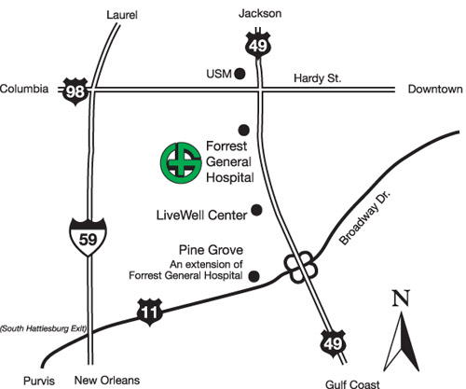

●NO FEE ●Lunch Provided ●Space is limited

You must register for this program:
LWhite@forrestgeneral.com or 601-707-0100

Invite your sponsor, bring a sponsee
All Anonymous Fellowships Welcome

Back to the Basics of Sponsorship

Saturday, June 1, 2013

9:00-09:45 am ~~ Introduction
Objectives of the Seminar
Having had a spiritual awakening . . .
What the “Big Book” says about Sponsorship
What a Sponsor Is and Is Not
9:45-10:00 am ~~ Break
10:00-10:45 am ~~ The History of Sponsorship
Emmanuel Movement
Oxford Group and Early A.A.
Concepts on Sponsorship from the 1940's
The Fifty Key Paragraphs in the “Big Book”
The Prison Cell of Addiction (Step 0)
10:45-11:00 am ~~ Break
11:00-12:15 pm ~~ Take Steps 1, 2, 3, and Setup Steps 4 and 5
Assign Sharing Partners
The Surrender (Steps 1, 2 and 3)
The Assets and Liabilities Checklist (Step 4)
Anger Management 101
With Whom Do We Share Our Inventories? (Step 5)
12:15-2:15 pm Lunch and Breakout Session
(Take Steps 4 and 5 with Sharing Partner)
2:15-3:00 pm ~~ Take Steps 6, 7, 8, 9, 10 and Setup Step 11
The Second Surrender (Steps 6 and 7)
Forgiveness and Restitution (Steps 8 and 9)
Four Types of Amends
Daily Inventory (Step 10)
Listening to the Indwelling Spirit (Step 11)
3:00-3:15 pm ~~ Break
3:15-4:00 pm ~~ Take Steps 11 and 12
Two-way and Three-way Prayer (Step 11)
Relaxation Exercises (Step 11)
Opening the Channels (Step 11)
Share Guidance (Step 11)
The Five C’s of Life-changing (Step 12)

