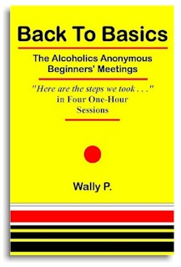
Jen D. and Chris B. are holding a step study on the 12 Steps of Alcoholics Anonymous using the Back to Basics literature developed by Wally P. We will work the 12 steps in four one hour sessions.
Please Come and Join the Step Study
The Back to Basics format uses Big Book references (page, paragraph and line) to describe each step’s intent and expected results. It is a good starting point for A.A. newcomers and a good refresher for members of the fellowship who have already worked the steps.

When: 10AM – 11AM, April 7, April 14, April 21, April 28 2018
Where: Old Presbyterian Meeting House “Flounder”
316 S Royal Street, Alexandria, VA 22314
PLEASE BRING A BIG BOOK & HIGHLIGHTER

